Assignment 2 - Technical Report
Comparative Evaluation of recent Chest X-Ray Classification Models
Course: Advanced Machine Learning
Name: Shifat Shadril Hassan ID: 22646203
GitHub repository: https://github.com/shadril238/advanced-ml-coursework/tree/main/assignment-2

This report includes an evaluation of six recent chest X-ray classification models across individual and combined dataset settings. The experiments use CheXpert, NIH ChestX-ray14, RSNA Pneumonia, and a combined (CheXpert + VinDr-CXR) dataset. This report summarizes data preparation, model settings, results, and reproduction steps.

1 Experimental setup

1.1 Individual datasets
I used CheXpert [1], NIH ChestX-ray14 [2], and RSNA Pneumonia [3] for the individual-dataset experiments. For CheXpert, CLEAR, EVA-X-S, CheXWorld, and GLoRIA evaluated the 202-image public validation split on five findings. AlphaRAD and RadZero instead used 668-image expert evaluation sets; AlphaRAD queried 12 findings and RadZero assessed five. On NIH ChestX-ray14, CLEAR, EVA-X-S, and CheXWorld evaluated the published 25,596-image test list, whereas RadZero used its released 22,433-image benchmark subset. For the binary RSNA Pneumonia task, AlphaRAD evaluated a 5,337-image reference split, while GLoRIA used a separate 70/15/15 training, validation, and test partition with 4,003 test images. Development data were separated by patient where identifiers were available. Because the CheXpert expert sets, the NIH subset, and the RSNA partitions differ from the other test sets, I interpret comparisons across those protocols as descriptive rather than controlled comparisons.
Table 1 summarizes the settings recorded in the 12 executed individual-dataset notebooks. The table reports the input procedure, batch size, optimization settings, and training duration for each experiment. Here, B denotes batch size, and 64×2×8 denotes a per-GPU microbatch of 64 on two GPUs with eight gradient-accumulation steps. Epoch counts refer to complete passes through the training data unless the notebook uses shorter training intervals. Zero-shot experiments apply released checkpoints without task-specific training; BCE denotes binary cross-entropy with logits, LR the learning rate, and WD weight decay.
Table 1 Hyperparameters in the individual notebooks
Model | Dataset | Input and batch | Training settings
CLEAR | CheXpert | Released preprocess; image B32, head B512 | Linear head; Adam LR 2×10⁻⁴, WD 0; BCE; ≤200 epochs; patience 10; 20 seeds (42–61)
CLEAR | NIH ChestX-ray14 | Released preprocess; image B32, head B512 | Linear head; Adam LR 2×10⁻⁴, WD 0; BCE; ≤200 epochs; patience 10; 20 seeds (42–61)
AlphaRAD | CheXpert | Official evaluator; inference B2 | Released checkpoint; zero-shot; 0 epochs; seed 1234
AlphaRAD | RSNA Pneumonia | DICOM→PNG; official evaluator; B2 | Released checkpoint; zero-shot; 0 epochs; seed 1234
EVA-X-S | CheXpert | Resize 256, crop 224; 64×2×8 | Full fine-tuning; AdamW LR 10⁻³, WD 0.05, layer decay 0.55; BCE; 60 short intervals; seed 14
EVA-X-S | NIH ChestX-ray14 | Official 224-pixel transform; 64×2×8 | Full fine-tuning; AdamW LR 10⁻³, WD 0.05, layer decay 0.55; BCE; 30 planned, 17 completed; warm-up 5; seed 0
CheXWorld | CheXpert | Resize 256, input 224; 32×2×4 | Full fine-tuning; AdamW LR 10⁻², WD 0.4, layer decay 0.55; BCE; 1 epoch; seeds 0–4
CheXWorld | NIH ChestX-ray14 | Resize 256, input 224; 32×2×4 | Full fine-tuning; AdamW LR 10⁻⁴, WD 0.05, layer decay 0.75; BCE; 15 epochs; seed 0
RadZero | CheXpert | Released 518×518 processor; inference B8 | Released checkpoint; zero-shot; 0 epochs; seed 42
RadZero | NIH ChestX-ray14 | Released 518×518 processor; inference B8 | Released checkpoint; zero-shot; 0 epochs; seed 42
GLoRIA | CheXpert | Center crop 224; image/head B64 | Frozen ResNet-50 + linear head; Adam LR 10⁻⁴, WD 10⁻⁶; BCE; 50 epochs; seed 42
GLoRIA | RSNA Pneumonia | DICOM→crop 224; image/head B64 | Frozen ResNet-50 + linear head; Adam LR 5×10⁻⁴, WD 10⁻⁶; BCE; ≤50 epochs; patience 10; seed 42

The six models represent distinct adaptation strategies. CLEAR [4] uses a released concept encoder and trains a linear classifier, while GLoRIA [5] uses released CheXpert ResNet-50 image weights with a newly trained classification head. EVA-X-S [6] and CheXWorld [7] fine-tune their image encoders. AlphaRAD [8] and RadZero [9] apply released vision–language checkpoints to text-defined findings without task-specific training. I retained the preprocessing specified in each notebook: for example, CheXWorld uses random resized cropping, horizontal flipping, and brightness/contrast jitter during training, whereas EVA-X-S follows its supplied training transform. Uncertain CheXpert labels and threshold-dependent predictions follow each notebook’s stated policy. The model experiments ran on Kaggle NVIDIA T4 GPUs; the encoder fine-tuning runs used two T4s with gradient accumulation. The executed notebooks record the checkpoint sources, software settings, training logs, and prediction outputs.
Official implementation repositories: CLEAR; AlphaRAD; EVA-X; CheXWorld; RadZero; GLoRIA.

1.2 Combined CheXpert and VinDr-CXR dataset
I constructed the combined dataset from 10,000 frontal CheXpert images [1] and 15,000 annotated VinDr-CXR images [10]. The shared image-level targets are Atelectasis, Cardiomegaly, Consolidation, and Pleural Effusion. For CheXpert, positive entries were retained as positive, uncertain (−1) entries were masked for the corresponding finding, and zero or blank entries were treated as negative. For VinDr-CXR, a finding was assigned a positive image-level label when at least two distinct radiologists marked it; all remaining images were negative for that finding. The preparation notebook packaged the images and train, validation, and test label files into a single ZIP archive. Table 2 reports the contribution of each source to the three splits.
Table 2 Combined-dataset image counts
Split | CheXpert | VinDr-CXR | Total
Training | 7,973 | 12,000 | 19,973
Validation | 1,026 | 1,500 | 2,526
Test | 1,001 | 1,500 | 2,501

Table 3 Combined-test label counts after harmonization
Finding | Observed | Positive | Prevalence | Masked
Atelectasis | 2,343 | 150 | 6.4% | 158
Cardiomegaly | 2,465 | 299 | 12.1% | 36
Consolidation | 2,367 | 84 | 3.5% | 134
Pleural Effusion | 2,456 | 457 | 18.6% | 45

Table 3 describes the observed labels in the common test split after harmonization. The four combined-model notebooks read the same packaged images and split assignments, and they use identical target and observation-mask columns. VinDr-CXR contributes only 11 positive Atelectasis cases and 13 positive Consolidation cases to the test split. Estimates restricted to these small source-specific positive groups are therefore unstable. Each model notebook applies its own input transformation when loading images from the shared archive.
Table 4 Hyperparameters in the combined-dataset notebooks
Model | Dataset | Input and batch | Training settings
AlphaRAD | CheXpert + VinDr-CXR | Official evaluator; inference B2 | Released checkpoint; zero-shot; 0 epochs; seed 1234; four finding queries
RadZero | CheXpert + VinDr-CXR | Released 518×518 processor; inference B8 | Released checkpoint; zero-shot; 0 epochs; seed 42; four released prompts
EVA-X-S | CheXpert + VinDr-CXR | Resize 256, crop 224; 64×2×8 | Full fine-tuning; masked BCE; AdamW LR 10⁻³, WD 0.05, layer decay 0.55; 20 epochs; seed 14
GLoRIA | CheXpert + VinDr-CXR | Center crop 224; image/head B64 | Frozen ResNet-50 + linear head; masked BCE; Adam LR 10⁻⁴, WD 10⁻⁶; ≤50 epochs; patience 10; seed 42

Table 4 records the model-specific hyperparameters used on the combined dataset. For trained models, masked BCE excludes unobserved CheXpert findings from the classification loss. AlphaRAD and RadZero score the four harmonized findings without fitting on the combined training split; EVA-X-S fine-tunes its encoder and GLoRIA trains a classifier on frozen image features. EVA-X-S uses two T4 GPUs and an effective batch size of 1,024. The common evaluation omits masked labels separately for each finding, calculates AUROC and area under the precision–recall curve (AUPRC) per finding, and averages these values without weighting across the four findings. Accuracy, precision, recall, and F1-score are reported at the decision thresholds specified by each notebook.

2 Results

2.1 Individual-dataset evaluation
Table 5 consolidates the outputs of the 12 individual-dataset notebooks. For multilabel experiments, AUROC is the unweighted mean across evaluated findings; accuracy, precision, recall, and F1-score are likewise reported as means of the per-finding values. The RSNA Pneumonia rows describe a binary task. The table should be read together with the split and label definitions in Section 1.1, since these experiments do not all share the same test images, findings, or adaptation protocol.
Table 5 Individual-dataset classification results
Model | Dataset | AUROC | Accuracy | Precision | Recall | F1-score
CLEAR | CheXpert | 0.876 | 0.816 | 0.671 | 0.636 | 0.614
EVA-X-S | CheXpert | 0.901 | 0.811 | 0.673 | 0.400 | 0.449
CheXWorld | CheXpert | 0.871 | 0.806 | 0.671 | 0.634 | 0.607
GLoRIA | CheXpert | 0.883 | 0.812 | 0.723 | 0.620 | 0.614
AlphaRAD | CheXpert | 0.893 | 0.856 | 0.554 | 0.310 | 0.318
RadZero | CheXpert | 0.900 | 0.728 | 0.373 | 0.924 | 0.519
CLEAR | NIH ChestX-ray14 | 0.778 | 0.857 | 0.220 | 0.417 | 0.280
EVA-X-S | NIH ChestX-ray14 | 0.825 | 0.926 | 0.349 | 0.118 | 0.160
CheXWorld | NIH ChestX-ray14 | 0.822 | 0.879 | 0.290 | 0.421 | 0.329
RadZero | NIH ChestX-ray14 | 0.804 | 0.703 | 0.113 | 0.742 | 0.180
AlphaRAD | RSNA Pneumonia | 0.832 | 0.778 | 0.631 | 0.067 | 0.122
GLoRIA | RSNA Pneumonia | 0.890 | 0.821 | 0.578 | 0.752 | 0.654

On the 202-image CheXpert public validation split, EVA-X-S achieved the highest five-finding AUROC (0.901) among the models evaluated on that split. Its recall at the reported threshold was 0.400, compared with 0.636 for CLEAR, 0.634 for CheXWorld, and 0.620 for GLoRIA. The separate 668-image expert evaluations show a different operating-point pattern: RadZero achieved recall of 0.924 with precision of 0.373, whereas AlphaRAD achieved precision of 0.554 with recall of 0.310. These expert-set results should not be ranked directly against the public-validation results because both the case mix and evaluated findings differ. CheXWorld’s five-seed mean AUROC was 0.871 after one training epoch, below the 0.896 reference value recorded in its notebook. Moreover, EVA-X-S selected a checkpoint using the public validation split, so its 0.901 AUROC is a descriptive result rather than an independent held-out estimate.
On NIH ChestX-ray14, EVA-X-S produced the highest reported macro AUROC (0.825) and accuracy (0.926). At a fixed 0.5 decision threshold, however, its mean recall was 0.118 and its F1-score was 0.160, indicating that many positive findings were missed at that operating point. CheXWorld achieved the highest F1-score among the NIH runs (0.329), while RadZero reached recall of 0.742 with precision of 0.113. The EVA-X-S notebook completed 17 of 30 planned epochs and used official-test AUROC for checkpoint selection; its score is therefore not an unbiased held-out estimate. RadZero also used a 22,433-image benchmark subset rather than the 25,596-image published test list used by the other NIH runs. These protocol differences restrict direct ranking of the NIH results.
For RSNA Pneumonia, AlphaRAD’s zero-shot classifier achieved precision of 0.631 but detected few positives at threshold 0.5, yielding recall of 0.067. The trained GLoRIA head obtained recall of 0.752 and an F1-score of 0.654 using a threshold of 0.310 selected on validation data. The two notebooks used different held-out partitions and different adaptation procedures. Their reported values therefore describe the behavior of each implemented workflow rather than a controlled comparison on one common test set.
Figures 1–12 present the ROC and precision–recall curves saved by the individual-dataset notebooks.
Figure 1 CLEAR ROC and precision–recall curves on CheXpert
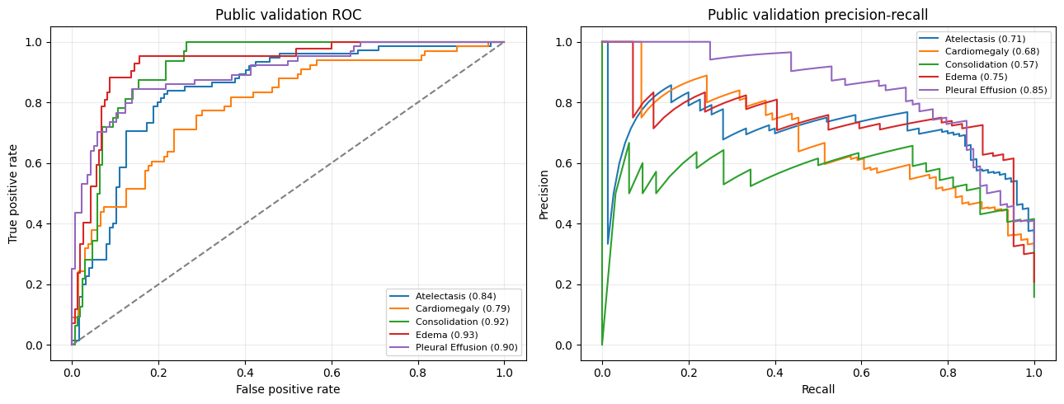
Figure 2 EVA-X-S ROC and precision–recall curves on CheXpert
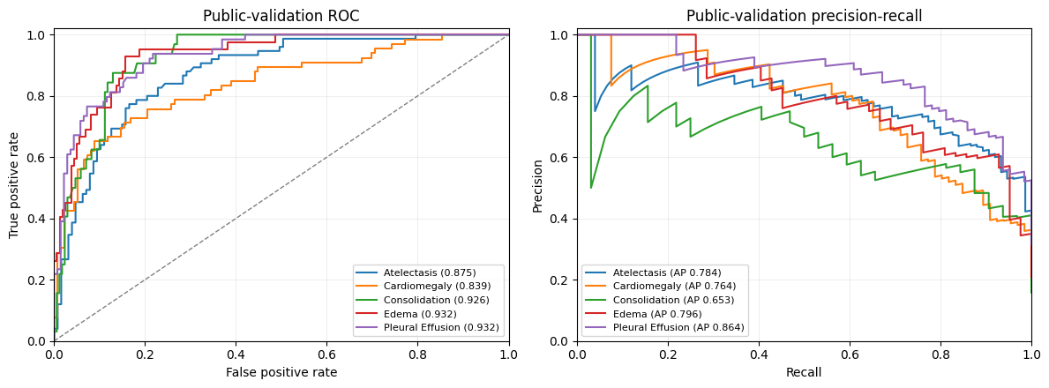
Figure 3 CheXWorld ROC and precision–recall curves on CheXpert
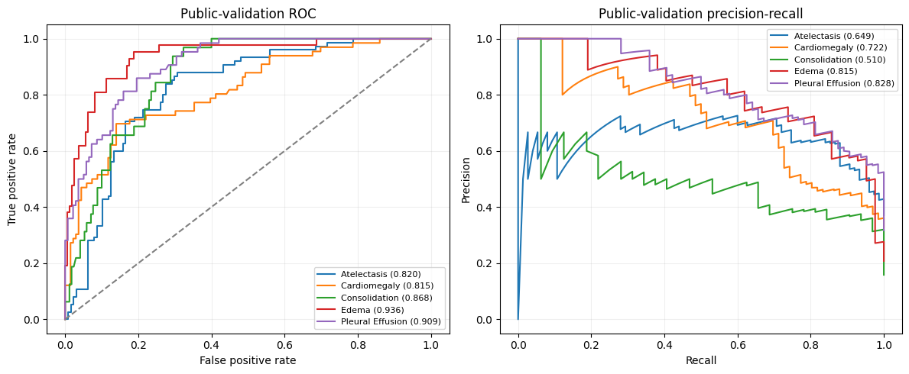
Figure 4 GLoRIA ROC and precision–recall curves on CheXpert
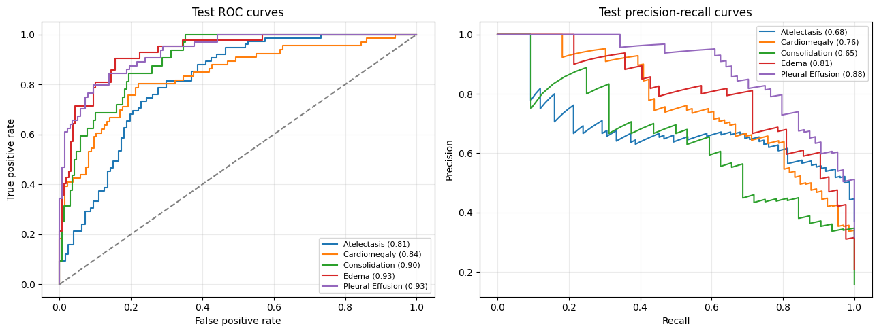
Figure 5 AlphaRAD ROC and precision–recall curves on CheXpert
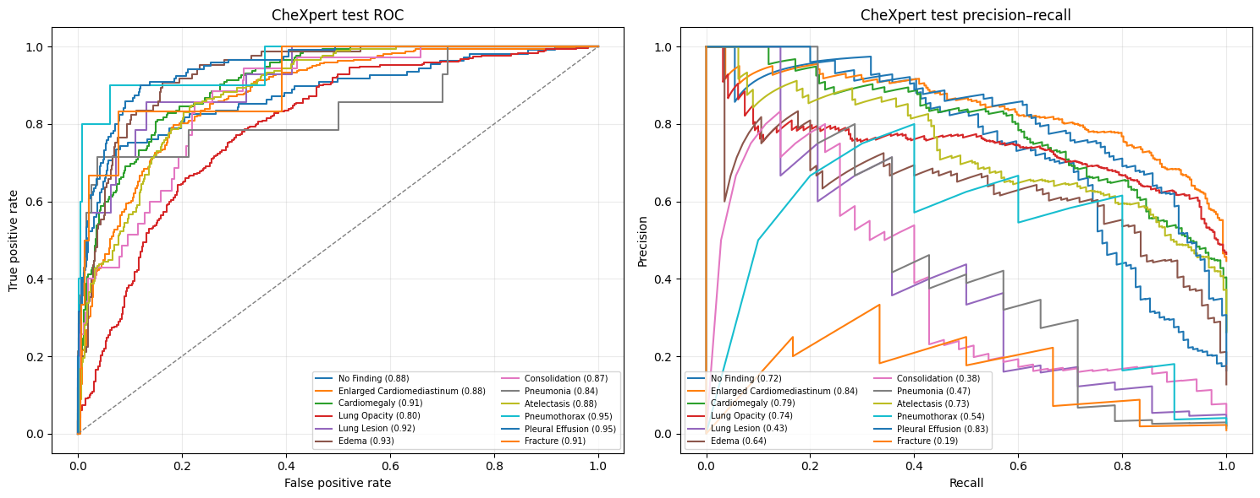
Figure 6 RadZero ROC and precision–recall curves on CheXpert
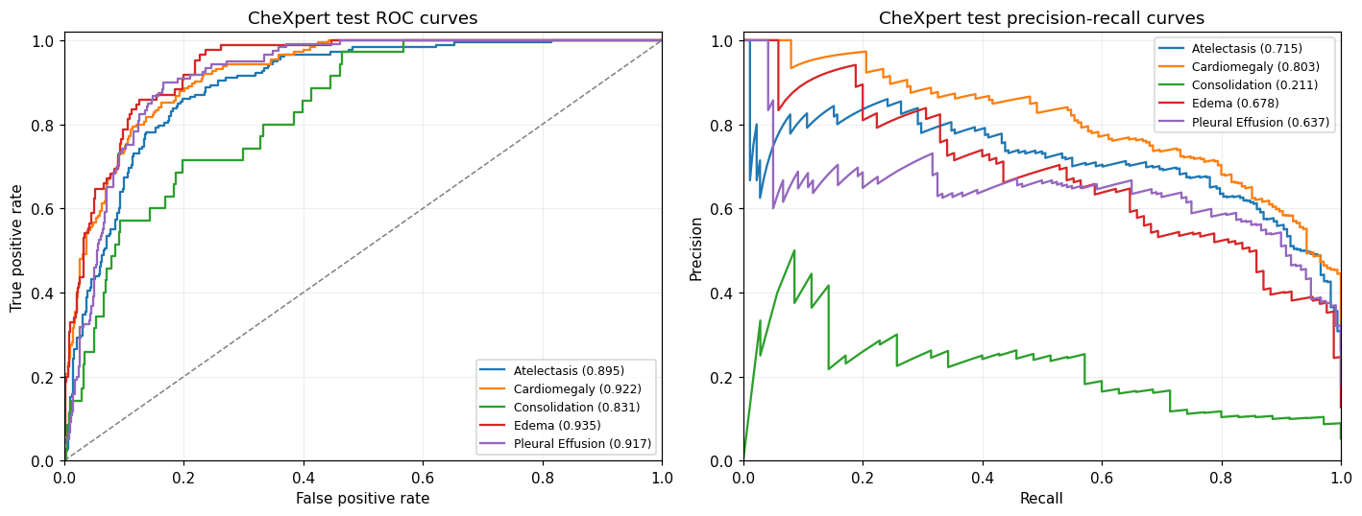
Figure 7 CLEAR ROC and precision–recall curves on NIH ChestX-ray14
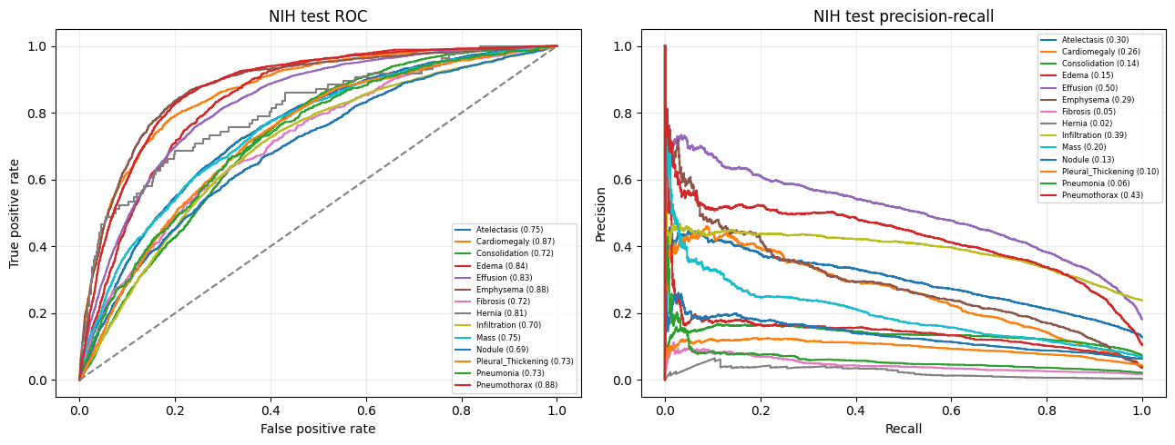
Figure 8 EVA-X-S ROC and precision–recall curves on NIH ChestX-ray14
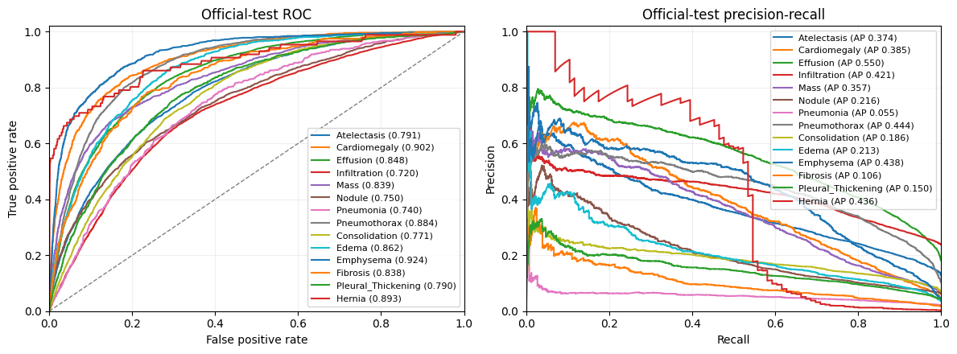
Figure 9 CheXWorld ROC and precision–recall curves on NIH ChestX-ray14
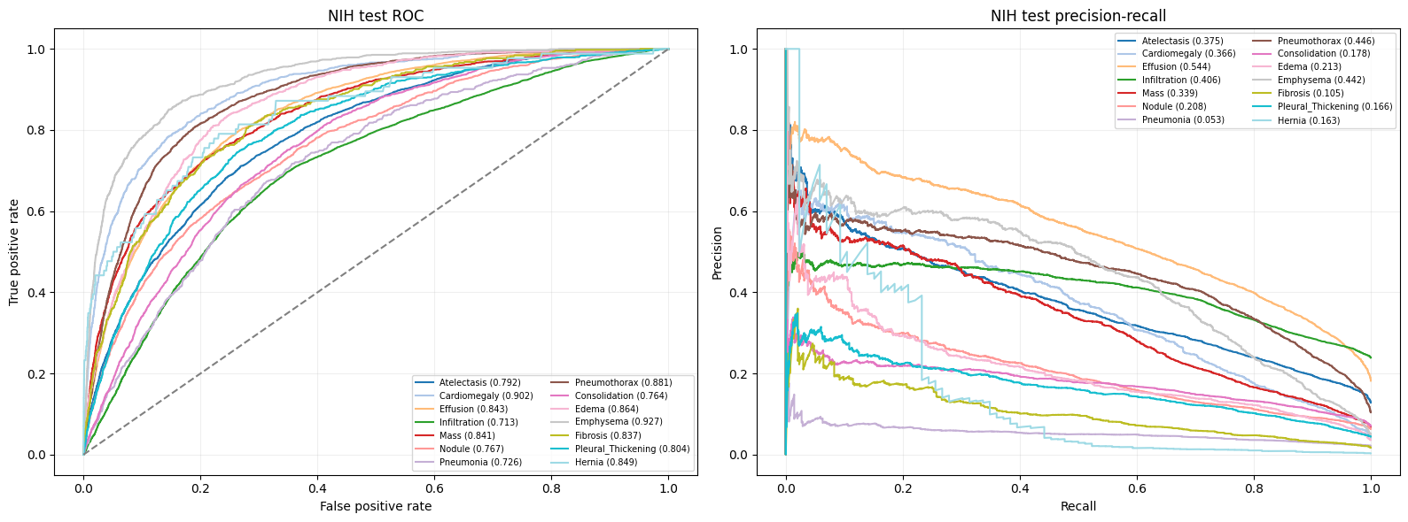
Figure 10 RadZero ROC and precision–recall curves on NIH ChestX-ray14
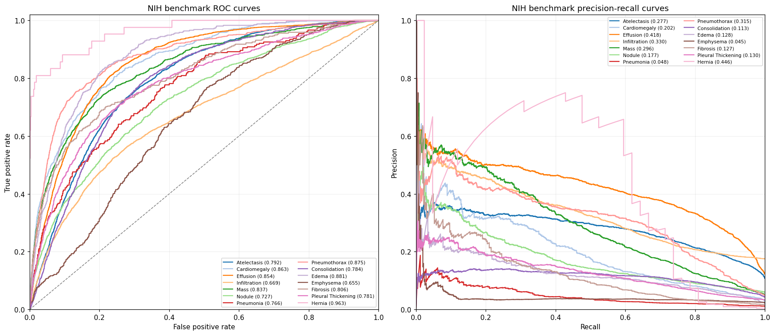
Figure 11 AlphaRAD ROC and precision–recall curves on RSNA Pneumonia
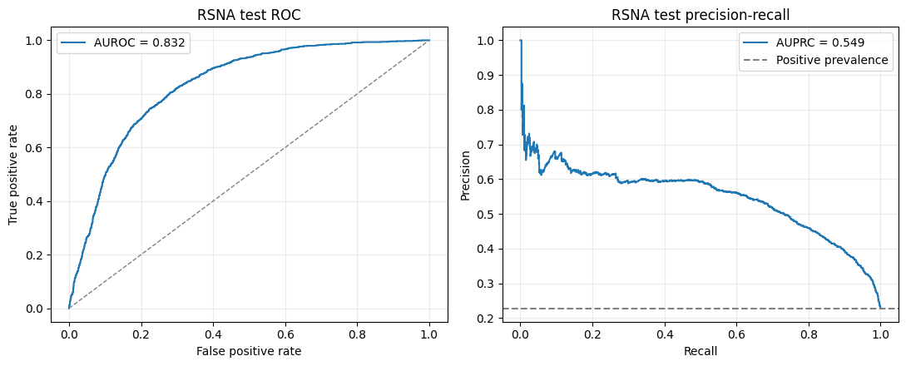
Figure 12 GLoRIA ROC and precision–recall curves on RSNA Pneumonia
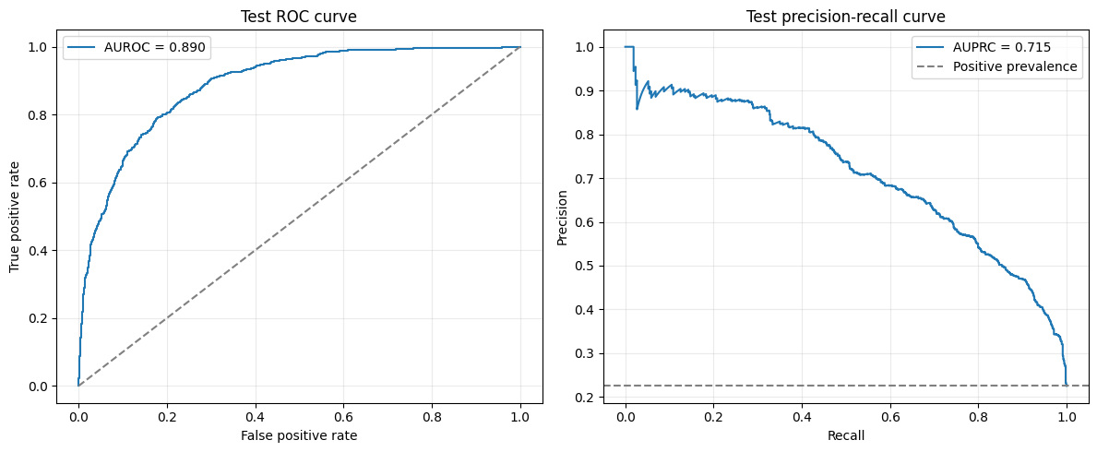

2.2 Combined-dataset evaluation
For the combined-dataset evaluation, all four models scored the same 2,501-image test manifest with the same four harmonized findings and observation masks. This shared test provides a more direct comparison of discrimination than the individual-dataset experiments.
Table 6 Combined-dataset classification results
Model | Dataset | AUROC | Accuracy | Precision | Recall | F1-score
AlphaRAD | CheXpert + VinDr-CXR combined dataset | 0.879 | 0.906 | 0.515 | 0.376 | 0.368
RadZero | CheXpert + VinDr-CXR combined dataset | 0.869 | 0.753 | 0.278 | 0.863 | 0.393
EVA-X-S | CheXpert + VinDr-CXR combined dataset | 0.925 | 0.934 | 0.539 | 0.468 | 0.476
GLoRIA | CheXpert + VinDr-CXR combined dataset | 0.912 | 0.907 | 0.457 | 0.591 | 0.506

EVA-X-S achieved the highest macro AUROC (0.925) and AUPRC (0.533) on the combined test, followed by GLoRIA (0.912 and 0.492, respectively). GLoRIA obtained the highest macro F1-score (0.506), using a separately optimized validation threshold for each finding. AlphaRAD, RadZero, and EVA-X-S used a fixed threshold of 0.5; consequently, the F1-scores reflect different threshold-selection policies as well as differences in model predictions. RadZero had the highest recall (0.863) but lower precision (0.278), consistent with a large number of false-positive predictions. Its accuracy of 0.753 should be interpreted in the context of the low prevalence of several positive findings rather than as a complete measure of performance.

The per-finding AUPRC results provide additional detail beyond the macro averages. EVA-X-S obtained the highest AUPRC for Atelectasis (0.331) and Cardiomegaly (0.788), whereas AlphaRAD obtained the highest values for Consolidation (0.216) and Pleural Effusion (0.831). Consolidation had only 84 observed positive cases, and all four models had relatively low AUPRC for this finding (0.178–0.216). Pleural Effusion had 457 observed positives and AUPRC close to 0.83 for three models. Figures 13–16 show ROC and precision–recall curves for each model on the same combined test. The curves illustrate that high AUROC does not necessarily translate into high precision for less common findings.
Figure 13 AlphaRAD ROC and precision–recall curves on the combined test
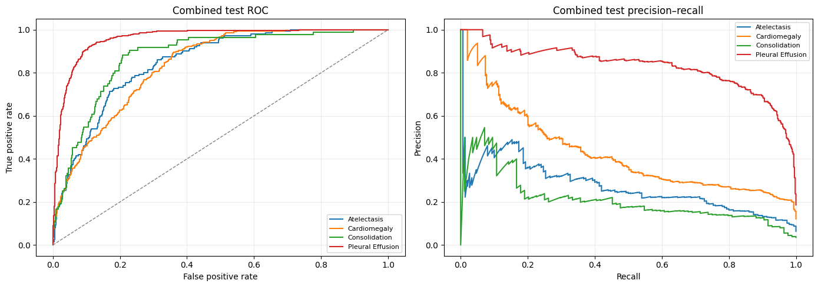
Figure 14 RadZero ROC and precision–recall curves on the combined test
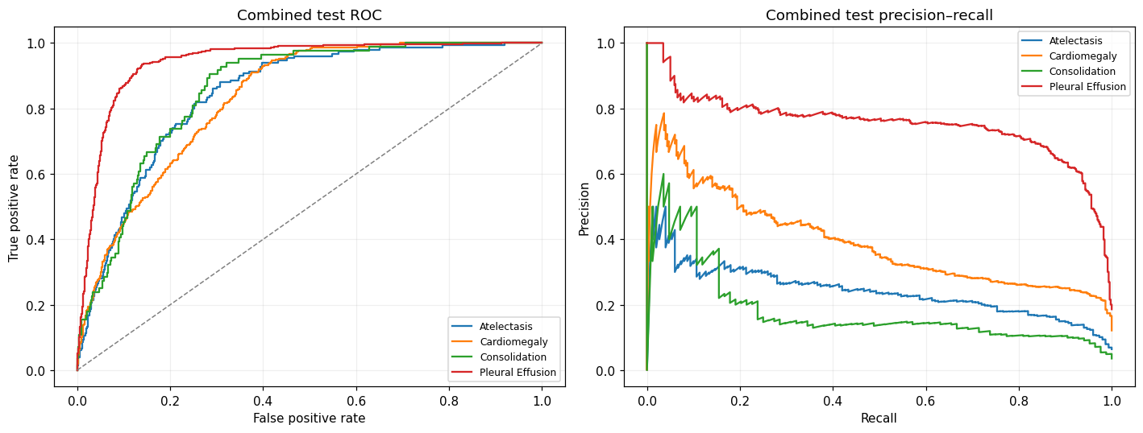
Figure 15 EVA-X-S ROC and precision–recall curves on the combined test
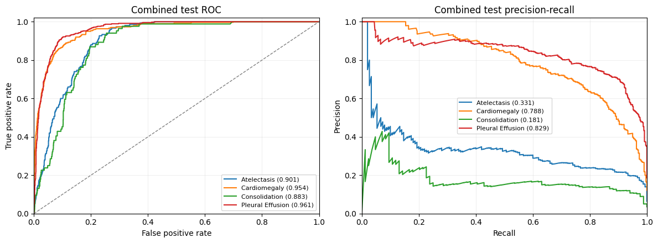
Figure 16 GLoRIA ROC and precision–recall curves on the combined test
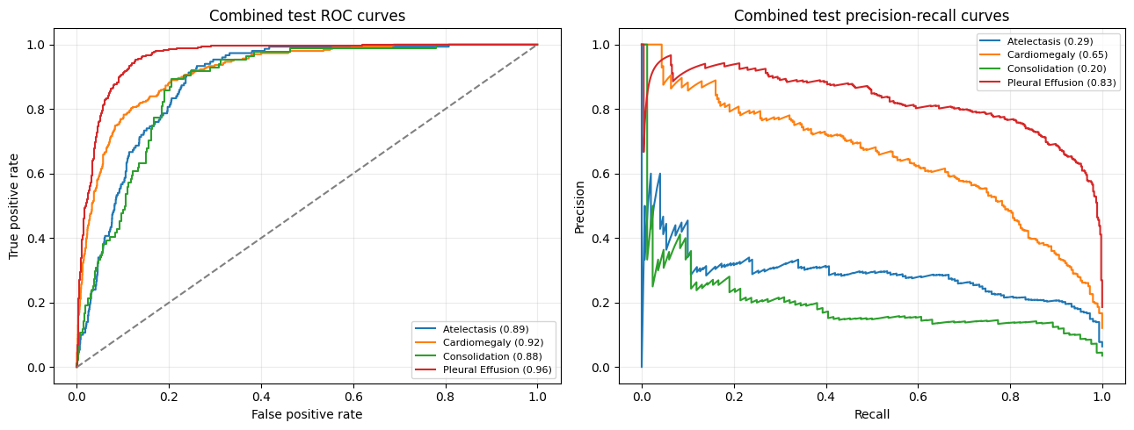

3 Reproduction guidelines
To repeat the individual-dataset experiments, import the relevant notebook into Kaggle, attach its named source dataset and any required released checkpoint, enable a T4 GPU and internet access where the notebook requires them, and execute all cells with the recorded settings. For the combined experiments, first run the dataset-preparation notebook with CheXpert, the 256-pixel VinDr-CXR image derivative, and the VinDr-CXR annotation CSV; save the resulting combined ZIP as a Kaggle notebook output. Attach that same ZIP and each model’s required weights to the four combined-model notebooks, then run all cells without changing the split files or evaluation masks. The assignment README identifies the input sources and notebook order. Save the executed Kaggle versions and retain the metrics, figures, predictions, and logs written under /kaggle/working/ so that the reported tables can be checked against the original outputs.

References
[1] Irvin, J., Rajpurkar, P., Ko, M., Yu, Y., Ciurea-Ilcus, S., Chute, C., ... & Ng, A. Y. (2019, July). Chexpert: A large chest radiograph dataset with uncertainty labels and expert comparison. In Proceedings of the AAAI conference on artificial intelligence (Vol. 33, No. 01, pp. 590-597). Available: https://stanfordmlgroup.github.io/competitions/chexpert/
[2] NIH Clinical Center, “NIH chest X-ray dataset.” [Online]. Available: https://nihcc.app.box.com/v/ChestXray-NIHCC
[3] Radiological Society of North America, “RSNA pneumonia detection challenge,” 2018. [Online]. Available: https://www.rsna.org/artificial-intelligence/ai-image-challenge/RSNA-Pneumonia-Detection-Challenge-2018
[4] T. Han, R. Wu, Y. Tian, F. Khader, L. C. Adams, K. K. Bressem, C. Davatzikos, J. N. Kather, L. Shen, D. A. Mankoff, E. M. Barbosa, Jr., and D. Truhn, “CLEAR: An auditable foundation model for radiology grounded in clinical concepts,” Nature Biomedical Engineering, 2026. [Online]. Available: https://doi.org/10.1038/s41551-026-01741-4
[5] S.-C. Huang, L. Shen, M. P. Lungren, and S. Yeung, “GLoRIA: A multimodal global-local representation learning framework for label-efficient medical image recognition,” in Proceedings of the IEEE/CVF International Conference on Computer Vision, 2021, pp. 3942–3951. [Online]. Available: https://doi.org/10.1109/ICCV48922.2021.00391
[6] J. Yao, X. Wang, Y. Song, H. Zhao, J. Ma, Y. Chen, W. Liu, and B. Wang, “EVA-X: A foundation model for general chest X-ray analysis with self-supervised learning,” npj Digital Medicine, vol. 8, p. 678, 2025. [Online]. Available: https://doi.org/10.1038/s41746-025-02032-z
[7] Y. Yue, Y. Wang, C. Tao, P. Liu, S. Song, and G. Huang, “CheXWorld: Exploring image world modeling for radiograph representation learning,” in Proceedings of the IEEE/CVF Conference on Computer Vision and Pattern Recognition, 2025, pp. 20778–20788. [Online]. Available: https://openaccess.thecvf.com/content/CVPR2025/html/Yue_CheXWorld_Exploring_Image_World_Modeling_for_Radiograph_Representation_Learning_CVPR_2025_paper.html
[8] J. You, Y. Gao, and C. McIntosh, “AlphaRAD: Grounded zero-shot classification in chest radiology via α-corrected binary cross entropy and factorized latent supervision,” in European Conference on Computer Vision, 2026. [Online]. Available: https://arxiv.org/abs/2609.01757
[9] J. Park, B. Yoon, S. Kim, and K. Choi, “RadZero: Similarity-based cross-attention for explainable vision-language alignment in chest X-ray with zero-shot multi-task capability,” in Advances in Neural Information Processing Systems, vol. 38, 2025. [Online]. Available: https://papers.neurips.cc/paper_files/paper/2025/hash/510e5c2fd5ad326f75594563f4ad5e0d-Abstract-Conference.html
[10] H. Q. Nguyen, H. H. Pham, l. tuan linh, M. Dao, and l. khanh, “VinDr-CXR: An open dataset of chest X-rays with radiologist annotations,” PhysioNet, version 1.0.0, 2021. [Online]. Available: https://doi.org/10.13026/3akn-b287

